A Data-Driven Study of Java’s Role and Demand in the Global Software Industry

Introduction-
Java has remained one of the most widely used programming languages for over two decades. Despite the rise of newer languages, Java continues to play a critical role in enterprise software, backend systems, cloud platforms, and large-scale applications.
This study analyses Java’s real-world demand, industry-relevant skills, and career opportunities for early-career developers, using job market data, industry reports, and technology adoption trends rather than theoretical definitions.
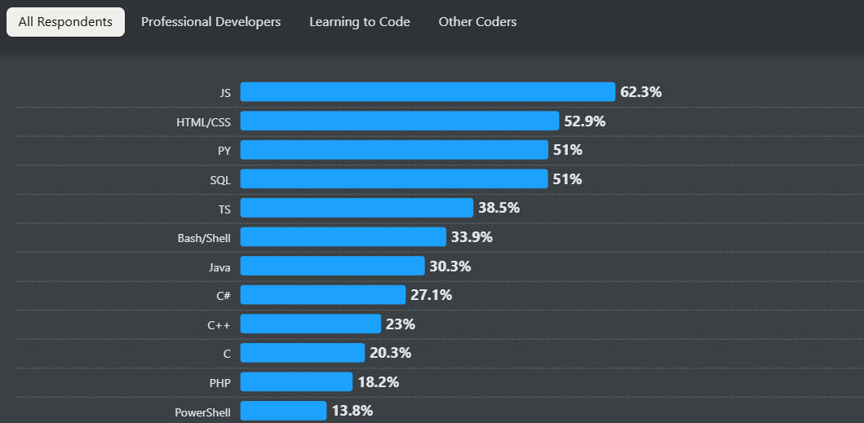
Figure 1 Most Popular Technologies, Source: Stack Overflow survey
Global Market Demand for Java-
- Job Market Demand-
Analysis from major job portals shows Java consistently ranking among the top backend programming skills globally.
Platform | Evidence of Java Demand
LinkedIn Jobs | Java appears in ~18–20% of backend developer job postings
Indeed | Java is mentioned in ~1 out of 5 software job listings
Naukri (India) | Java is consistently in the top 5 most demanded IT skills
Glassdoor | Java roles dominate enterprise and backend hiring

Java demand is stable rather than declining. Unlike trend-driven languages, Java demand is sustained by long-term enterprise systems that require maintainability and scalability.
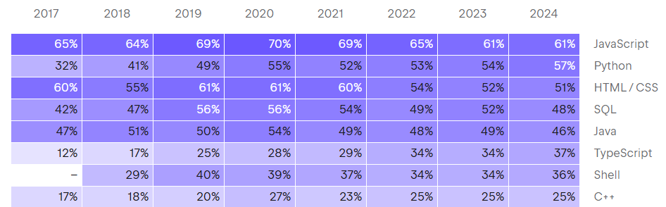
Figure 2 Programming, Scripting, and Markup Language Usage (2017–2024), Source: JetBrains State of Developer Ecosystem Report 2024

- Geographic Demand-
High-demand regions include: India, United States, Germany, United Kingdom and Singapore
Primary reasons for demand:
- Banking & FinTech platforms
- Telecom infrastructure
- Government IT systems
- Large-scale SaaS applications
Industry Sectors Actively Using Java-
Industries that prioritize stability, security, and scalability consistently prefer Java over short-lived technology stacks.
Industry | Java Usage
Banking & Finance | Core banking platforms, payment processing systems
E-commerce | Order management systems, backend APIs
Cloud & SaaS | Microservices-based backend services
Telecom | High-throughput distributed systems
Government | Long-term, stable, maintainable software systems

Modern Java Trends-
- Evolution of Java- Enterprises strongly prefer LTS versions, as confirmed by industry ecosystem reports.
Version | Industry Impact
Java 8 | Functional programming (Streams, Lambdas) – still widely used
Java 11 | Long-Term Support (LTS) enterprise adoption
Java 17 | Current enterprise-preferred standard
Java 21 | Performance, virtual threads, and concurrency improvements

- Java in Microservices & Cloud- Modern Java development has moved away from monolithic architectures.
Industry practices include:
- Spring Boot for RESTful services
- Microservices-based architecture
- Docker & Kubernetes for deployment
- Cloud-native Java services on AWS, Azure, and GCP
Result:
Java remains cloud-ready and competitive with Node.js and Go in backend engineering.
Industry-Relevant Java Skill Stack-
- Must-Have Skills-
Category | Skills
Core Java | OOP, Collections, Streams, Exception Handling
Backend | Spring Boot, REST APIs
Databases | SQL, JPA/Hibernate
Tools | Git, Maven/Gradle
Fundamentals | JVM architecture, memory management

- High-Value Add-On Skills- Industry hires Java developers who understand systems and architecture, not just syntax.
Skill | Industry Value
Microservices | Very High
Docker & Kubernetes | High
Cloud (AWS/GCP/Azure) | High
Kafka / Messaging Systems | Medium–High
System Design Basics | Critical
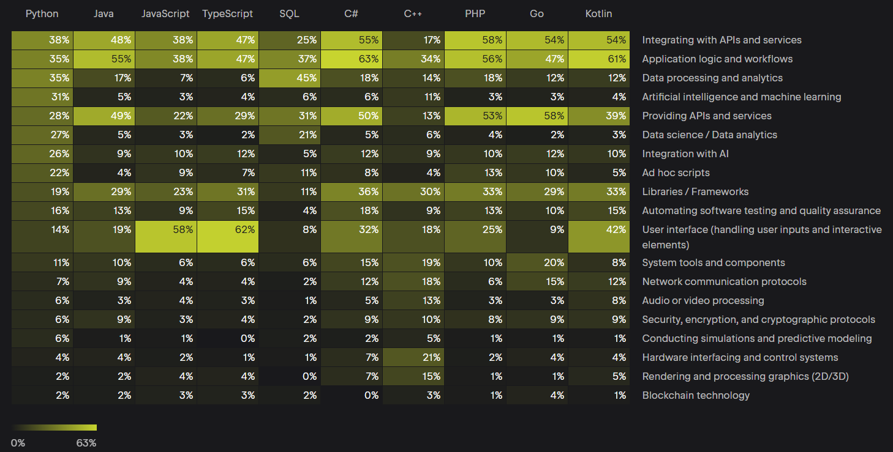
Figure 3 Code Functionality by Primary Programming Language, Source: JetBrains State of Developer Ecosystem Report 2024
This chart shows the primary functionalities handled by different programming languages. Java is mainly used for backend application logic, APIs, security, and system-level components. This confirms Java’s strong position in enterprise and backend development, where reliability and scalability are more important than rapid UI development.
Skill Gap Analysis: Academia vs Industry- The largest gap lies in real-world system exposure, not language basics.
Area | Academia | Industry
Java Fundamentals | Strong | Expected
Framework Usage | Limited | Mandatory
Debugging & Logs | Minimal | Daily Requirement
System Design | Rare | Core Skill
Deployment & DevOps | Almost None | Essential

Java vs Other Backend Technologies- Java remains the preferred choice for high-traffic, mission-critical systems.
Metric | Java | Node.js | Python
Performance | High | Medium | Low–Medium
Scalability | Excellent | Good | Moderate
Enterprise Adoption | Very High | Medium | Medium
Learning Curve | Moderate | Easy | Easy
Long-Term Stability | Very High | Medium | Medium

Salary & Career Progression- Java careers offer slow but stable growth, favoring long-term career security.
Entry-Level Java Developer (0–2 Years Experience)
Region | Average Annual Salary
India | ₹4–8 LPA
USA | $70,000–95,000
Europe | €45,000–65,000

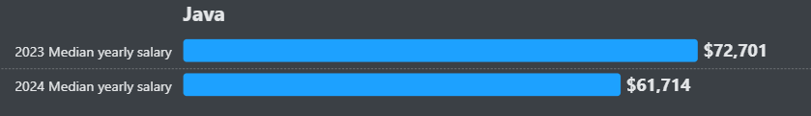
Figure 4 Change in salaries between 2023 and 2024, Source: Stack Overflow Survey

Career Growth Path-

Case Study: Real-World Java Systems-
Large-scale banking platforms handle millions of transactions every day and therefore require software systems that are highly reliable, secure, and scalable. Java is widely preferred in such environments because it provides strong support for transaction management and concurrency control, which are critical for ensuring data consistency during simultaneous financial operations. Frameworks built on Java offer robust mechanisms to handle multi-threaded processing without compromising system stability.
Another major reason for Java’s adoption in banking systems is its mature and well-tested security ecosystem. Java provides extensive libraries and frameworks for encryption, authentication, and secure communication, which are essential for protecting sensitive financial data. In addition, the Java Virtual Machine (JVM) allows performance tuning and memory optimization, enabling banking applications to maintain high throughput under heavy load conditions.
From a long-term perspective, Java-based systems are easier to maintain and evolve compared to newer or less stable technologies. Banking software often remains in production for decades, and Java’s backward compatibility and long-term support versions allow organizations to upgrade systems gradually without major disruptions. The key takeaway from this case study is that, at large scale, evolving and optimizing existing Java systems is significantly safer and more cost-effective than rewriting critical banking applications from scratch.
Cloud & Microservices Readiness- Java plays a dominant role in enterprise cloud-native systems.
- Over 60% of enterprise microservices are Java-based
- Spring Boot is among the most widely adopted backend frameworks
Critical Analysis & Future Outlook-
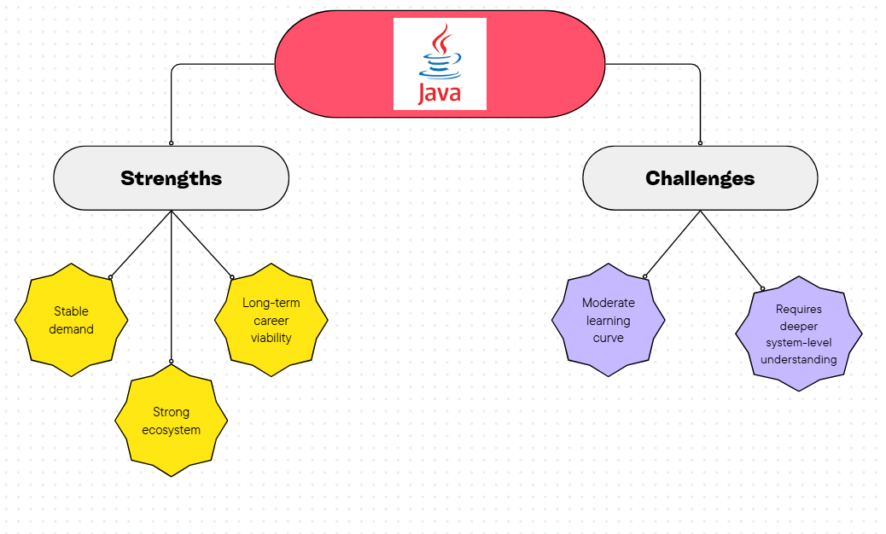
Java will continue evolving with:
- Greater focus on architecture
- Increased cloud-native adoption
- Fewer entry-level-only coding roles
Conclusion-
Java remains one of the most reliable and future-proof career options for early-career developers targeting backend, cloud, and enterprise roles.
Success depends on:
- Understanding systems beyond syntax
- Learning frameworks and cloud tooling
- Aligning academic learning with industry expectations
References-
- LinkedIn Jobs – Java Developer Listings
https://in.linkedin.com/jobs/java-developer-jobs
- Indeed – Java Developer Job Listings
https://www.indeed.com/q-java-developer-jobs.html
- Naukri Skill Demand Reports (India)
https://www.naukri.com/java-jobs
- Glassdoor – Entry-Level Java Developer Salaries (India)
https://www.glassdoor.co.in/Salaries/entry-level-java-developer-salary-SRCH_KO0,26.htm
- Stack Overflow Developer Survey (Technology Trends)
https://survey.stackoverflow.co/2024/technology
- JetBrains – State of the Developer Ecosystem (Java)
https://www.jetbrains.com/lp/devecosystem-2024/
- Oracle – Java Long-Term Support & Version Strategy
https://www.oracle.com/java/technologies/java-se-support-roadmap.html
- Spring Boot Adoption & Microservices
https://spring.io/why-spring

